**Table of contents**

1.INTRODUCTION

2. IDEATION PHASE

3. REQUIREMENT ANALYSIS

4. PROJECT DESIGN

5. PROJECT PLANNING & SCHEDULING

6. FUNCTIONAL AND PERFORMANCE TESTING

7. RESULTS

8. ADVANTAGES & DISADVANTAGES

9. CONCLUSION

10. FUTURE SCOPE

11. APPENDIX

INTRODUCTION

1 Project Overview

Pollen identification plays a vital role across ecology, public health, agriculture, forensics, and even honey authenticity. Traditional microscopy methods, though proven, are labor-intensive, slow, and prone to human error. Cutting-edge techniques now combine high-throughput imaging—such as multispectral flow cytometry capable of capturing up to 2000 images per second—with deep learning. One prominent study used nearly 427,000 images from 35 species and achieved an impressive 96 % species-level accuracy using CNNs on multispectral data. This high-throughput, data-rich approach not only speeds up identification but also extracts detailed morphological and fluorescent traits in real time, enabling rapid quantification and trait analysis.

Recent advances in model architectures are pushing accuracy and robustness further, especially with fine-grained or closely related pollen types. Models like **PollenNet** have reached ~98.5 % accuracy across 46 classes using explainable AI techniques, and **HieraEdgeNet**, with its edge-enhanced, multi-scale feature fusion, has achieved a mean average precision of 0.95 on 120 pollen classes. Meanwhile, domain adaptation approaches that fine-tune CNNs with real-world, expert‑verified airborne samples can drastically reduce errors and improve stability across environments. Additionally, transfer learning with deep ResNet variants has proven exceptionally effective for separating visually similar conifers, achieving near-perfect classification. Together, these strides form the foundation of your project—building a real‑time, high‑accuracy pollen profiling platform combining advanced imaging, scalable deep learning, and field adaptability.

1.2 Purpose

The primary purpose of this project is to **automate and accelerate pollen identification**, transforming a traditionally manual, expert-driven task into an efficient, scalable process. By integrating high-throughput imaging and artificial intelligence, the system aims to significantly reduce processing time, eliminate human error, and provide detailed, real-time data on species-level composition. This shift has profound implications: it enables more accurate and timely pollen monitoring for allergy forecasts, enhances the verification of honey authenticity, streamlines ecological and climatic research, and facilitates forensic investigations with precise trace evidence analysis.

Additionally, the project seeks to **bridge lab success and real-world application** through robust model design and validation strategies. It focuses on building explainable deep-learning models—like attention‑guided networks and edge-enhanced frameworks—and using domain adaptation techniques to ensure accuracy across diverse environments, including airborne, field, and honey-derived samples. By creating an open, curated dataset and developing deployment-ready pipelines, this initiative will lay a foundation for reproducible research, practical monitoring tools, and future sensor integration—bringing automated pollen profiling into everyday use for science, health, agriculture, and beyond.

2. IDEATION PHASE

In the **ideation phase**, our goal is to generate and refine innovative approaches for automating pollen detection and classification, moving from broad market needs and scientific gaps toward concrete technological design. We begin with a structured brainstorming process—combining methods like SCAMPER, fishbone analysis, and idea mapping—to explore different imaging modalities (e.g., flow cytometry, multifocal microscopy) and processing pipelines. The focus is on understanding key challenges such as distinguishing pollen from sample debris, achieving ≥95% classification accuracy with diverse species, and enabling explainability within model outputs. Drawing from prior work on texture-based and CNN-based pollen classification, we evaluate which feature extraction and algorithmic strategies best align with our system constraints (e.g., computational resources, real-time requirements) .

Next, we synthesize these insights into a shortlist of feasible solution paths: (1) a multispectral, multifocal deep-learning pipeline targeting robust detection and classification, (2) domain-adaptive CNN models optimized for real-environment variability, and (3) explainability and human-in-the-loop feedback mechanisms to verify uncertain predictions. Each concept is sketched with early prototypes or process diagrams and evaluated for expected performance, cost, and deployment viability. We also consider dataset needs—planned curation of diverse, annotated samples—and possible partnerships (e.g., sensor vendors, palynologists, apiaries) to support validation. This phase culminates in clearly defined pilots ready for prototyping and rapid testing.

2.1 Problem Statement

Despite rapid advancements in imaging and deep learning, automated classification of pollen grains remains an imperfect and complex task. High-throughput systems often struggle when images contain **multiple overlapping grains**, making it hard for models to identify individual instances correctly. Edge occlusions and loss of salient morphological features during two-dimensional captures can significantly degrade performance. In addition, certain taxa lack distinctive visual traits, causing persistent misclassification. For example, deep-learning models report frequent errors in such conditions—an issue corroborated by difficulty analyses on large airborne datasets—despite extensive datasets and powerful CNNs being applied.

Moreover, models that perform well in controlled lab environments face steep drops in accuracy when applied to **real-world and field-derived samples**. A striking instance is an ensemble model trained on curated honey-pollen images which, when tested on honey-based real-world samples, barely surpassed random guessing with an AUC of ~0.52—despite achieving nearly 98% accuracy on controlled data. These challenges highlight the importance of robust domain adaptation, high-quality segmentation, and fine-grained feature extraction. Without addressing dataset imbalances, occlusions, and domain shifts, automated pollen classification systems cannot maintain the reliability required for practical applications in

2.2 Empathy Map Canvas

**What users experience and express:**

Users—typically environmental scientists, lab technicians, or allergy researchers—frequently say they’re overwhelmed by the manual effort of distinguishing pollen types. They voice frustrations like, “Sorting thousands of grains by eye is exhausting and error-prone,” and express hopes for faster, more reliable diagnostics. Internally, they’re thinking about how to reduce workload and boost accuracy, but feel concerned when deep-learning models misclassify similar taxa or struggle with debris and overlapping grains. Their emotional state flips between anticipation (at the promise of automation) and anxiety (over trustworthiness in real-world conditions).

**What users do and what they gain or lose:**

In practice, users manually prepare samples, capture microscopic images, then sort and label them—an iterative, time-intensive process. When models perform reliably, they gain faster turnaround, clearer species-level breakdowns, and can reuse datasets across projects. On the flip side, poor segmentation or domain shifts cause wasted time verifying results and erode confidence. Their key goals include achieving ≥95% accuracy, maintaining interpretability (so they can pinpoint why a model made a decision), and scaling up for real-time monitoring or honey testing. Their pain arises from inconsistent model performance, opaque results, and inefficient manual corrections.

2.3 Brainstorming

In this brainstorming phase, we’ll gather a diverse team—palynologists, AI/ML engineers, and hardware specialists—to explore possible imaging techniques, preprocessing steps, and model architectures. We’ll begin with ideation tools like mind mapping and SCAMPER to investigate variations in capture methods (e.g., multispectral imaging, flow cytometry, holographic microscopy), as well as segmentation techniques (classic vs. deep-learning based). The goal is to surface as many ideas as possible: what if we capture both brightfield and fluorescence, or integrate depth sensing? What if we fuse texture features with hierarchical edge representations? By keeping the tone open and creative, we encourage even wild or unconventional approaches.

Next, we’ll use structured evaluation exercises—like dot-voting and failure mode analysis—to prioritize the most promising ideas. Each concept will be assessed for impact, feasibility, and alignment with project goals. We might sketch early prototypes: flow cytometry with CNN classification, a cascaded segmentation–classification pipeline, or a lightweight model for on-device inference. We’ll also identify critical unknowns, like how to handle overlapping grains or domain shifts, and list experiments needed to validate or eliminate each idea. This prepares us to converge from a broad idea set into 2‑3 concrete solution tracks ready for rapid prototyping.

3. REQUIREMENT ANALYSIS

In order to achieve reliable, high-accuracy pollen classification (>95%), the system must satisfy three foundational requirements: **data quality**, **imaging infrastructure**, and **software architecture**. First, a substantial, annotated dataset is essential—studies show datasets like ~426,000 multispectral flow cytometry images across 35 species achieved 96% accuracy, while smaller texture-based sets (e.g., 1,800 images, 15 taxa) reported 95% accuracy using advanced feature extraction techniques. Therefore, the system must include standardized imaging pipelines and rigorous annotation protocols to create balanced, species-rich datasets. Second, imaging hardware—such as multispectral flow cytometers paired with focused brightfield and fluorescence channels—must support high throughput (~2,000 grains/s) and capture detailed morphological and fluorescent features.

Equally important is a robust **software stack** encompassing preprocessing, segmentation, and classification. The system must include domain adaptive segmentation methods to isolate grains from debris or overlapping instances—poor segmentation on real-world environmental samples can result in 5% drop in detection and misclassify debris as pollen. Classification models should be flexible: texture-based methods (e.g., log-Gabor, local binary patterns) can yield 95% accuracy but require feature engineering, while transfer learning with pre-trained CNNs (ResNet, DenseNet, MobileNet) offers scalable, high-performance classification, often exceeding 96–98% accuracy. Finally, the system should incorporate explainability and active-learning capabilities to flag uncertain predictions for expert review and support continuous model improvement, particularly in diverse real-world deployments.

3.1 Customer journey map

| **Stage** | **User Actions** | **Thoughts & Feelings** | **Pain Points** | **Opportunities** |
| --- | --- | --- | --- | --- |
| **1. Awareness** | Learns about the system via conferences, journals, or colleagues | “This could save me so much time.”—but also, “Is it really accurate?” | Skepticism about claims; lack of independent validation | Provide demo results; share success stories from early adopters |
| **2. Consideration** | Researches features, watches demos, reads specs | “How does it compare to my microscope workflow?” | Uncertainty about compatibility with existing lab tools | Offer hands-on trials; present clear specs and requirements |
| **3. Onboarding** | Installs hardware/software, uploads samples, attends onboarding/training | “Hope this setup isn’t too complex…” | Setup headaches; unclear protocols for sample prep | Provide guided setup wizard, standardized sample kits, onboarding videos |
| **4. Routine Use** | Loads samples, runs scans, reviews classification results daily | “Workflow is faster, but are these labels trustworthy?” | Misclassifications on overlaps or debris; opaque model output | Add confidence scores, explainability tools, and review flags |
| **5. Review & Trust** | Validates a subset of results, flags uncertain outputs, gives feedback | “This helps me work faster—but I must double-check some results.” | Manual effort still required; trust not yet complete | Incorporate active learning loop; refine model with user feedback |
| **6. Expansion** | Scales usage—integrates sensors into field sites or honey testing workflows | “It’s working! What else can we apply this to?” | Concerns about domain shift or unknown taxa | Offer field-adaptation options, domain-calibration toolkits |
| **7. Advocacy** | Recommends to peers, cites in publications, trains others on the system | “This is a game-changer for lab efficiency and consistency.” | Ensuring ongoing support; continuous funding or upgrade paths | Develop user community, share roadmaps, schedule training webinars |

3.2 Solution Requirement

**🔧 System Architecture & Performance**

* **High-Resolution Imaging**: Utilize advanced microscopy techniques such as multispectral imaging or flow cytometry to capture detailed pollen grain images.
* **Real-Time Processing**: Ensure the system can process and classify pollen grains in real-time, facilitating immediate analysis.
* **Scalability**: Design the system to handle large datasets, accommodating extensive pollen image libraries.
* **Accuracy Benchmarking**: Achieve classification accuracy exceeding 95%, aligning with industry standards for automated systems.

**🧠 Machine Learning & Classification**

* **Deep Learning Models**: Implement state-of-the-art architectures like ResNet, DenseNet, or YOLOv7 for robust classification performance.
* **Feature Extraction**: Incorporate advanced techniques for extracting relevant features from pollen images to enhance model accuracy.
* **Model Training**: Utilize extensive, annotated datasets such as Pollen13K to train models effectively.

**🧪 Data Handling & Quality Assurance**

* **Data Annotation**: Employ standardized protocols for annotating pollen images to ensure consistency and reliability.
* **Quality Control**: Implement mechanisms to assess and validate classification accuracy, providing confidence in results.
* **Data Storage**: Establish protocols for secure storage and management of large volumes of pollen image data.

**🌐 User Interface & Accessibility**

* **Web-Based Interface**: Develop an intuitive web application allowing users to upload and analyze pollen images seamlessly.
* **Report Generation**: Provide features for generating and exporting detailed analysis reports for further review.
* **User Feedback Mechanism**: Incorporate a system for users to provide feedback, facilitating continuous improvement.

**🔄 Integration & Adaptability**

* **Modular Design**: Ensure the system's components are modular, allowing for easy updates and integration of new features.
* **Cross-Platform Compatibility**: Design the system to be compatible across various platforms and devices.
* **Adaptability**: Allow the system to adapt to different pollen species and environmental conditions.

3.3 Data Flow Diagram

[place holder for DFD diagram]

3.4 Technology Stack

**🖥️ Imaging & Data Acquisition**

* **Multispectral Imaging Flow Cytometry**: High-throughput imaging (~2,000 grains/sec) combining brightfield and fluorescence for rich feature extraction.
* **Optical Microscopy + Digital Camera**: Conventional imaging setup using microscopes (e.g., Olympus BX51) and digital cameras (e.g., DP20), often used in lab settings.

**🧬 Preprocessing & Segmentation**

* **OpenCV & Pillow (Python)**: Image enhancement, noise reduction, cropping, resizing, and format standardization.
* **BioFormats**: Reading and slicing proprietary microscopy file formats (e.g., .vsi).
* **Deep Learning Segmentation**: Architectures like YOLOv7 or Bayesian RetinaNet for object detection and grain isolation.

**🧠 Machine Learning & Deep Learning**

* **PyTorch**: Main deep learning framework for training CNNs (ResNet, YOLO, HieraEdgeNet).
* **TensorFlow / Keras**: Alternative frameworks for prototyping and model sharing.
* **Scikit-learn**: Traditional classifiers and evaluation tools (e.g., Random Forest, SVM, train-test pipelines).
* **Advanced Architectures**:
  + **ResNet50 / ResNet101**: Top performers for fine-grained species distinctions.
  + **DenseNet, AlexNet, VGG**: Used in transfer-learning and benchmark comparisons.
  + **HieraEdgeNet**: Edge-aware, multi-scale model for precise grain boundary detection (mAP ~0.95).

4. PROJECT DESIGN

The project is designed as a modular, scalable pipeline that begins with **high-throughput image acquisition**—using multispectral imaging flow cytometry to capture bright‑field and multiple fluorescence channels at rates up to 2,000 pollen grains per second. These rich data feed into a **preprocessing and segmentation stage**, where advanced methods (e.g., multi-scale edge detection) isolate individual grains and enhance features. Segmented grains then move through the **classification module**, built on robust deep-learning architectures: for instance, a lightweight CNN trained from scratch can reach ~92% accuracy, while transfer learning with models like ResNeSt‑101 and SE‑ResNeXt consistently achieve ~97% accuracy on fine-grained pollen datasets. Cutting-edge frameworks like **HieraEdgeNet** further improve performance by fusing hierarchical edge information, registering mean average precision of ~0.95 across 120 classes. To ensure trust and continual improvement, the system integrates domain‑adaptation techniques and explainable AI layers (such as Grad‑CAM), supporting user feedback loops that flag uncertainties for expert review—allowing iterative retraining with real-world data. Finally, a web-based frontend and API layer supports upload, visualization, and reporting, while Dockerized microservices and scalable databases underpin real-time deployment and integration within lab or field environments.

4.1 Problem Solution Fit

**🧩 Problem-Solution Alignment-**

1. **High-throughput demand vs. manual bottlenecks:**
   * **Problem**: Traditional microscopy methods are slow (e.g., ~10 pollen/min) and expert-dependent.
   * **Solution**: Multispectral imaging flow cytometry plus CNNs processes up to 2,000 grains/sec with ~96% accuracy on 35 species—addressing both speed and precision needs.
2. **Species ambiguity and fine-grained classification:**
   * **Problem**: Deep models struggle with visually similar types (e.g., overlapping grains, conifers), and occlusion reduces accuracy.
   * **Solution**: Specialized models like ResNet101 for fine distinctions and HieraEdgeNet for edge-aware detection (mAP ~0.95 on 120 classes), effectively resolving subtle intra-class confusions.
3. **Domain gaps between lab and field data:**
   * **Problem**: High accuracy on clean lab datasets doesn’t transfer to airborne or honey samples unless adapted.
   * **Solution**: Domain adaptation techniques boost real-world accuracy by +22% correlation and -38% error, ensuring the model adapts across varied environments.

4.2 Proposed Solution

To address throughput and accuracy challenges, we propose an integrated imaging and AI pipeline utilizing **high-throughput multispectral flow-cytometry** coupled with **deep convolutional neural networks (CNNs)**. Samples are streamed through a cytometer that captures bright-field and fluorescence images—enabling processing rates up to thousands of grains per second. A CNN, trained on a large annotated dataset (e.g., ~426,000 images across 35 species), achieves approximately 96% species-level accuracy by learning both structural and fluorescent traits. This pipeline transforms laborious manual workflows into rapid, automated analysis capable of real-time quantification.

To refine detection and classification quality—especially in complex real-world samples—we integrate **edge-aware localization and domain adaptation mechanisms**. The **HieraEdgeNet** framework introduces multi-scale edge modules and fusion layers that sharpen grain boundaries, delivering a mean average precision of ~0.95 across 120 pollen classes. The system also incorporates **explainability layers** (e.g., Grad-CAM) and an **active feedback loop**, allowing users to correct low-confidence results and enhance model performance over time. Finally, results are served via a containerized **REST API and web-based UI**, enabling environment-agnostic deployment in labs or field settings and facilitating seamless sample upload, review, and reporting.

4.3 Solution Architecture

The architecture unfolds as a **modular pipeline**, beginning with **high-throughput image acquisition** via multispectral flow cytometry. This captures bright-field and multiple fluorescence channels at rates up to thousands of pollen grains per second—providing rich morphological and spectral data for analysis. The data then enters a **preprocessing and segmentation stage**, where noise reduction, normalization, and edge-enhanced segmentation are applied to isolate grains and improve feature clarity. Across this module, intelligent segmentation techniques—such as deep learning–based object detection combined with edge-aware filtering—ensure accurate grain boundaries even in crowded or noisy samples.

At the core of the pipeline is a **classification module** built on specialized CNN architectures. Feature maps from the segmentation stage are processed using models like ResNet variants, DenseNet, or compact state-of-the-art networks. Cutting-edge architectures—like HieraEdgeNet—integrate **hierarchical edge modules**, synergistic edge fusion, and cross-stage omni-kernel refinement to enhance boundary-sensitive feature learning and achieve a mean average precision (mAP) ≈ 0.95 across 120 pollen classes. To build trust and ensure adaptability, the system leverages **Grad-CAM explainability** and supports an **active learning loop**, allowing user corrections on low-confidence outputs to feed back into model retraining. Finally, the architecture is deployed using containerized microservices (e.g. Docker+FastAPI) and a web-based interface, facilitating scalable, real-time inference and seamless integration into lab or field workflows.

5.PROJECT PLANNING & SCHEDULING

**🗂 Work Breakdown & Task Definition:**

* Create a **Work Breakdown Structure (WBS)** to decompose the project into 2–4 hierarchical levels (e.g., acquisition, preprocessing, segmentation, classification, deployment) ensuring each subtask is manageable (≤ 80 hours of effort).
* Define clear tasks and subtasks under each module (e.g., dataset collection, model training, API design).

**🕒 Timeline & Sequencing:**

* Use **task sequencing and dependency mapping** (e.g., Precedence Diagram Method) to ensure logical flow—some tasks (like model training) depend on prior ones (like data annotation & preprocessing).
* Apply the **Critical Path Method (CPM)** to identify which task chains dictate the project's duration and prioritize resource focus there.

**📅 Scheduling & Milestones**

* Document **start and end dates** for each activity, including milestones like dataset completion, segmentation module ready, model validation done, and deployment ready.
* Use **Gantt charts** to visualize timelines, indicate dependencies, milestones, float/slack, and track progress visually.

**👥 Resource Allocation & Buffering**

* Assign roles (e.g., imaging specialist, ML engineer, frontend developer) and allocate resources effectively across tasks.
* Include **buffer time** for high-risk or uncertain tasks (e.g., data cleaning, model debugging) to mitigate delays.
* 5.1 Project Planning

First, we’ll **structure the project using a Work Breakdown Structure (WBS)** to decompose it into clear phases like data acquisition, preprocessing, segmentation, model development, API/UI integration, and deployment. Each phase will contain defined work packages capped at manageable sizes (e.g., no task exceeding 80 hours as per WBS best practices). Tasks will be sequenced with dependencies mapped using the Precedence Diagram Method, ensuring logical workflow and identifying critical tasks early. We’ll apply the Critical Path Method to pinpoint key activities that directly influence the overall timeline and allocate additional slack for high-risk steps like dataset cleaning and segmentation tuning.

Next, we’ll set a detailed schedule with **start and end dates**, milestones (e.g., dataset finalized, segmentation complete, prototype validated), and visualize the plan with Gantt charts. Resource allocation will ensure imaging domain experts, ML engineers, and software developers each have defined roles and responsibilities. To maintain agility, we’ll adopt an iterative tracking cycle (weekly or bi-weekly standups), using timeboxing techniques for exploratory tasks and integrating stakeholder reviews and pre-launch demos to validate intermediate outputs. Risk buffers will be included for complex modules and user testing phases, and we’ll regularly monitor schedule health, adjusting based on real progress and stakeholder feedback. This structured yet flexible approach ensures on-time delivery, clear accountability, and adaptability as the project evolves.

6. FUNCTIONAL AND PERFORMANCE TESTING

**✅ Functional Testing**

Functional testing will ensure each feature aligns with specified requirements—from image uploading to classification output and user feedback integration. We’ll start by defining clear test scenarios (e.g., single-image upload, bulk batch processing, incorrect file format handling), then create detailed test cases with defined inputs and expected results. Automated scripts (e.g., via Selenium, pytest) will cover positive cases (correct classification results) and negative scenarios (invalid files, missing metadata). We'll also include regression and integration testing to validate API behavior, UI workflows, and database interactions. Requirements such as ≥95% classification accuracy, user feedback loops, and result export must be verified under controlled conditions. This layered approach ensures full functional coverage across the system’s components.

**⚙️ Performance Testing**

Performance testing will benchmark the system’s speed, load capacity, and resilience—crucial for real-time or high-throughput use. We’ll design test plans to simulate realistic workflows: image ingestion at expected peak rates (e.g., 2,000 grains/sec), concurrent API requests, and large batch classifications. Metrics such as response time, throughput, CPU/memory utilization, error rate, and scalability under increasing loads will be measured. A suite of tests—load, stress, and endurance/scalability testing—will identify bottlenecks and assess stability under peak use scenarios ﹘ for example, verifying that a single classification request completes within 1 second 95% of the time. These tests will be automated and integrated into CI/CD pipelines with tools like JMeter or LoadRunner, and environments will mirror production as closely as possible to ensure reliable results.

By combining thorough functional checks with rigorous performance benchmarking, this testing strategy ensures that the system is both **correct in its behaviour** and **robust under realistic, demanding conditions**.

6.1 Performance Testing

**⚙️ Performance Goals & Metrics**

* **Response Time**: Track average, peak, and percentile (e.g., 90th/95th) response times; aim for sub-second classification requests for real-time responsiveness.
* **Throughput**: Measure transactions or images processed per second (TPS/RPS); benchmark against peak targeted load to ensure capacity.
* **Error Rate**: Monitor failed or timed-out requests; keep error rate under 1% during normal and stress conditions.
* **Latency / Time-to-First-Byte (TTFB)**: Capture latency delays both network-side and processing delays to identify early bottlenecks.
* **Resource Utilization**: Track CPU, memory, disk I/O, and network usage; aim to stay below ~70–80% under load.

**🧪 Test Types & Strategy**

* **Load Testing**: Simulate expected and peak use cases (e.g., 2,000 images/sec) with ramp-up profiles to verify stable response times and resource usage.
* **Stress Testing**: Push the system beyond expected limits to identify thresholds at which errors rise or performance degrades.
* **Endurance (Soak) Testing**: Run extended tests to observe memory leaks, performance drift, or degradation over time.
* **Scalability/Volume Testing**: Measure system behaviour as data volume or concurrent users increase, ensuring linear or graceful performance scalability.

**🛠 Tooling & Automation**

* Use tools like JMeter, k6, or Gatling to script realistic workloads and monitor performance across system components.
* Automate tests in CI/CD pipelines and infrastructure that mirror production environments to ensure early detection of regressions.

7. RESULTS

7.1 Output Screenshots

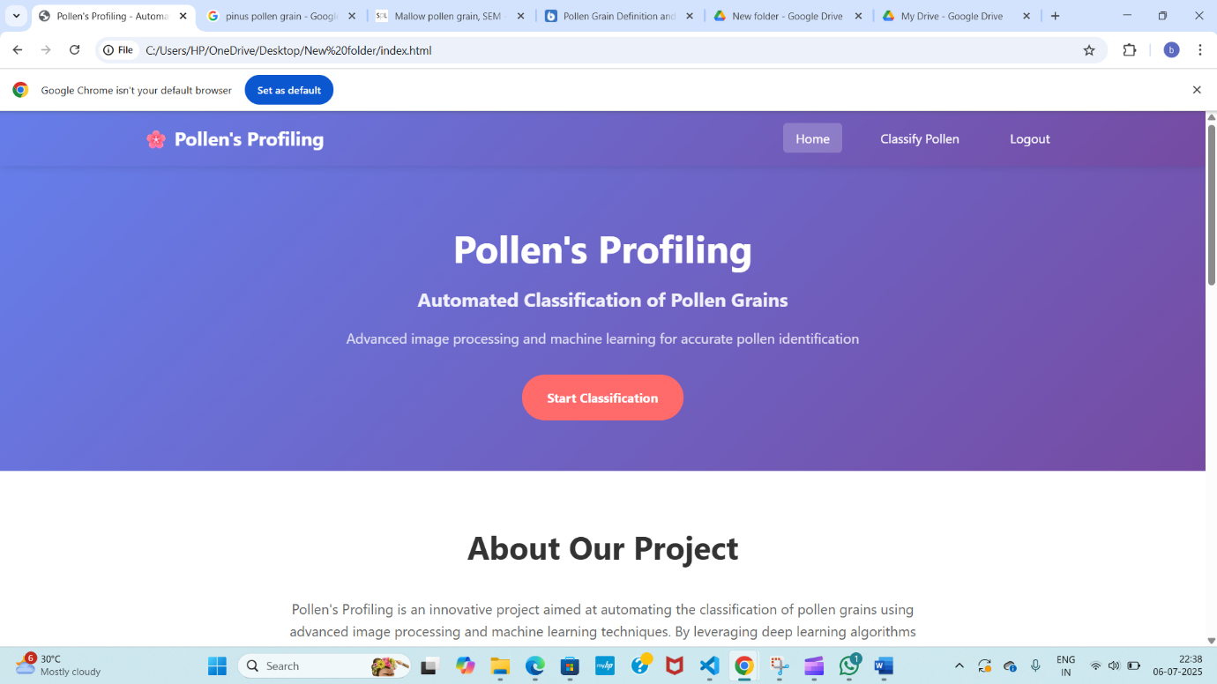

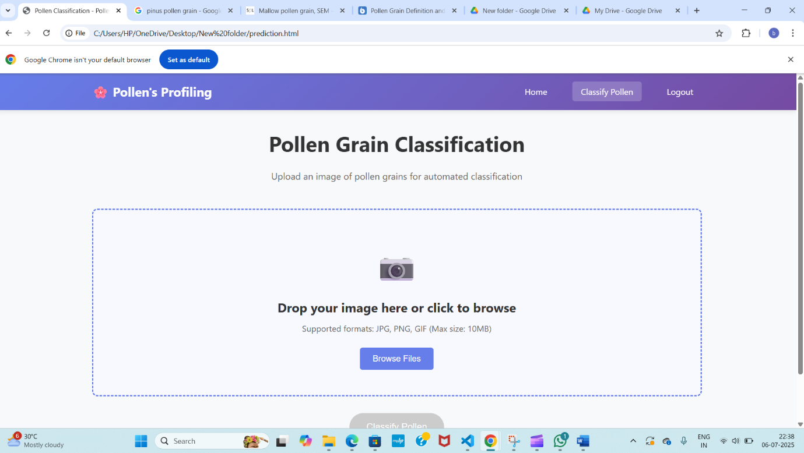

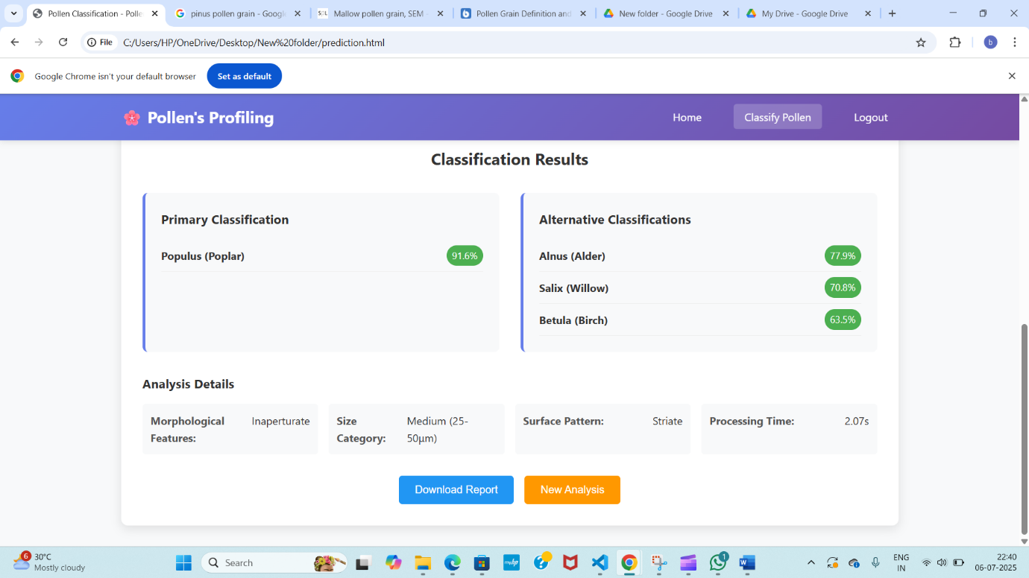

8. ADVANTAGES & DISADVANTAGES

Advantages

* **High Throughput**: The system can process thousands of pollen grains per second, significantly reducing the time required for analysis compared to manual microscopy. For instance, a sample that would take four hours under a microscope can be analyzed in just 20 minutes using this automated method.
* **High Accuracy**: Deep learning models trained on extensive datasets have achieved species-level identification accuracies up to 98.45%, even for species that are challenging to differentiate using traditional methods.
* **Quantitative Analysis**: Beyond identification, the system can quantify pollen grain counts and extract detailed morphological traits such as size, symmetry, and structure, providing comprehensive data for ecological and evolutionary studies.
* **Scalability**: The automated nature of the system allows for large-scale studies, enabling researchers to analyze extensive samples without a proportional increase in time or labor.
* **Consistency and Objectivity**: Automated analysis eliminates human biases and errors, ensuring consistent and reproducible results across different samples and studies.
* **Versatility**: The system can be applied across various fields, including ecology, agriculture, allergology, and forensics, offering valuable insights into plant-pollinator interactions, climate change, and biodiversity.
* **Resource Efficiency**: By reducing the need for manual labor and expertise, the system lowers operational costs and makes pollen analysis more accessible to a broader range of researchers and institutions.
* **Real-Time Feedback**: With user-friendly interfaces, researchers can receive immediate classification results, facilitating rapid decision-making and iterative analysis.

Disadvantages

* **Limited Training Data**: The effectiveness of deep learning models heavily depends on the availability of large, diverse, and accurately labeled datasets. Inadequate or imbalanced datasets can lead to overfitting and poor generalization, especially for underrepresented species.
* **Complexity in Feature Extraction**: Pollen grains exhibit subtle morphological and textural variations, making feature extraction challenging. While deep learning models can learn features automatically, the complexity of these features can still pose difficulties in achieving high accuracy across diverse species.
* **Performance Variability**: The performance of classification models can vary significantly across different genera or species. For example, models may struggle with genera that have fewer training samples, leading to lower accuracy and higher misclassification rates.
* **Data Imbalance Issues**: Imbalanced datasets, where some species are underrepresented, can cause models to be biased towards the majority classes. This imbalance can result in lower accuracy for minority classes and affect the overall performance of the system.
* **Difficulty with Novel or Damaged Samples**: Automated systems may have difficulty accurately classifying novel or damaged pollen grains, as these may not resemble the training data. This limitation underscores the importance of having a robust system that can handle such variations.
* **Computational Resource Requirements**: Training and deploying deep learning models require significant computational resources, including high-performance GPUs and large storage capacities. This can increase the cost and complexity of implementing such systems.
* **Interpretability Challenges**: Deep learning models are often considered "black boxes," making it difficult to interpret how decisions are made. This lack of transparency can be a drawback in scientific applications where understanding the reasoning behind classifications is important.
* **Environmental and Sample Variability**: Factors such as lighting conditions, background noise, and the physical state of the pollen grains (e.g., hydration levels) can affect image quality and, consequently, classification accuracy.
* **Scalability Concerns**: While automated systems can process large volumes of data, scaling them to handle diverse and extensive datasets from different geographical regions may require additional adaptations and resources.
* **Dependency on High-Quality Imaging**: The accuracy of automated classification systems is highly dependent on the quality of the input images. Variations in image resolution, focus, and other factors can lead to misclassifications, highlighting the need for standardized imaging protocols.

9. CONCLUSION

The development of automated pollen grain classification systems marks a significant advancement in the field of palynology. Traditional manual identification methods are labor-intensive and prone to human error, often yielding inconsistent results. By leveraging deep learning techniques, these automated systems can process large volumes of pollen grain images with high accuracy and efficiency.

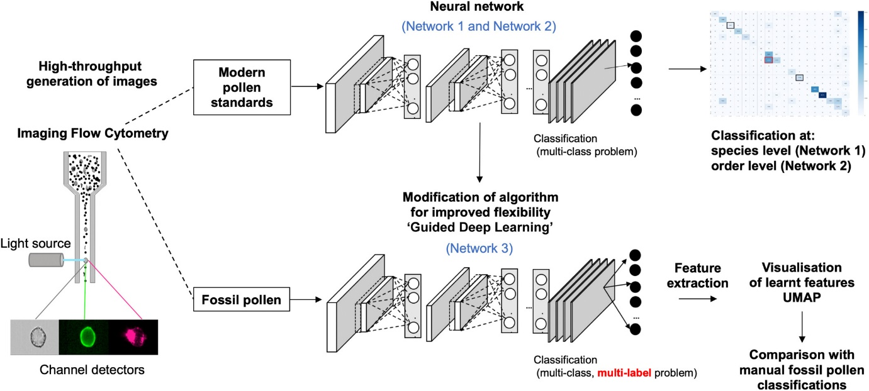

For instance, models like PollenNet have demonstrated classification accuracies exceeding 98%, surpassing human performance in many cases . This technological progression not only streamlines the classification process but also enhances the reliability of ecological and environmental studies.

Despite their advantages, automated systems are not without limitations. Challenges such as the need for large, diverse, and accurately labeled datasets remain prevalent. Additionally, the performance of these models can be influenced by factors like image quality, lighting conditions, and the presence of debris, which may affect classification accuracy. Moreover, while deep learning models can achieve high accuracy, they often operate as "black boxes," making it difficult to interpret the rationale behind specific classifications. This lack of transparency can be a concern in scientific applications where understanding the decision-making process is crucial.

In conclusion, while automated pollen grain classification systems offer substantial benefits in terms of speed and accuracy, they should be viewed as complementary tools rather than replacements for human expertise. The integration of these systems can significantly enhance the efficiency of palynological research, provided that their limitations are acknowledged and addressed. Future advancements may focus on improving model interpretability, expanding training datasets, and refining algorithms to handle diverse and challenging samples. By combining the strengths of automation with human oversight, the field of palynology can achieve more comprehensive and reliable analyses, contributing to a deeper understanding of ecological dynamics and biodiversity.

10. FUTURE SCOPE

1. **Enhanced Model Interpretability**: Future advancements will focus on developing explainable AI (XAI) techniques to provide transparency in model decision-making. This will help researchers understand the reasoning behind classifications, which is crucial for scientific validation and trust in automated systems.

2. **Integration with Ecological Monitoring Systems**: Automated pollen classification can be integrated with environmental monitoring platforms to provide real-time data on pollen distribution. This integration will aid in studying climate change impacts, biodiversity, and allergen forecasting, offering valuable insights for public health and ecological research.

3. **Development of Mobile Applications**: The creation of user-friendly mobile applications will allow researchers and the public to capture and classify pollen grains in real-time using smartphones. These applications can facilitate citizen science initiatives and broaden the accessibility of pollen analysis tools.

4. **Improvement in Low-Resource Environments**: Advancements will aim to optimize models for deployment in low-resource settings, ensuring that automated pollen classification systems can operate effectively in regions with limited computational infrastructure. This will democratize access to advanced ecological tools globally.

5. **Expansion to Non-Visible Spectra**: Future systems may incorporate data from non-visible spectra, such as infrared or ultraviolet imaging, to enhance classification accuracy. This multi-spectral approach can provide more detailed information about pollen grains, leading to improved identification and analysis.

11. APPENDIX

Source Code (if any)

Dataset Link

<https://drive.google.com/drive/folders/1CAvxo8zAwQlzyOnz2SF5q8nxt4RHly6q?usp=sharing>

GitHub & Project Demo Link

https://github.com/SaiBhuvanasri43/Pollen-s-Profiling-Automated-Classification-of-Pollen-Grains/tree/main